**FRONTEND WIREFRAME DOCUMENT**

**Hubba - REGISTRATION**

Version 1.0

Prepared By: Development Hell

Class: CECS 491-04

Date: February 19, 2023

Github Repository**:**

[**https://github.com/DevelopmentHellaHell/SeniorProject**](https://github.com/DevelopmentHellaHell/SeniorProject)

**Team Leader**

Kevin Dinh

**Members**

Garrett Tsumaki

Bryan Tran

Jett Sonoda

Tien Nguyen

Darius Koroni

# Table of Contents

Table of Contents 2

Registration – Success Case 3

Registration – Failure Case: Email Existed 8

Registration – Failure Case: Other Error Messages 9

Network Error 9

Passwords do not match 10

Email input field is empty 11

Password input field is empty 12

Email is invalid 13

Password is invalid 14

References 15

# Registration – Success Case

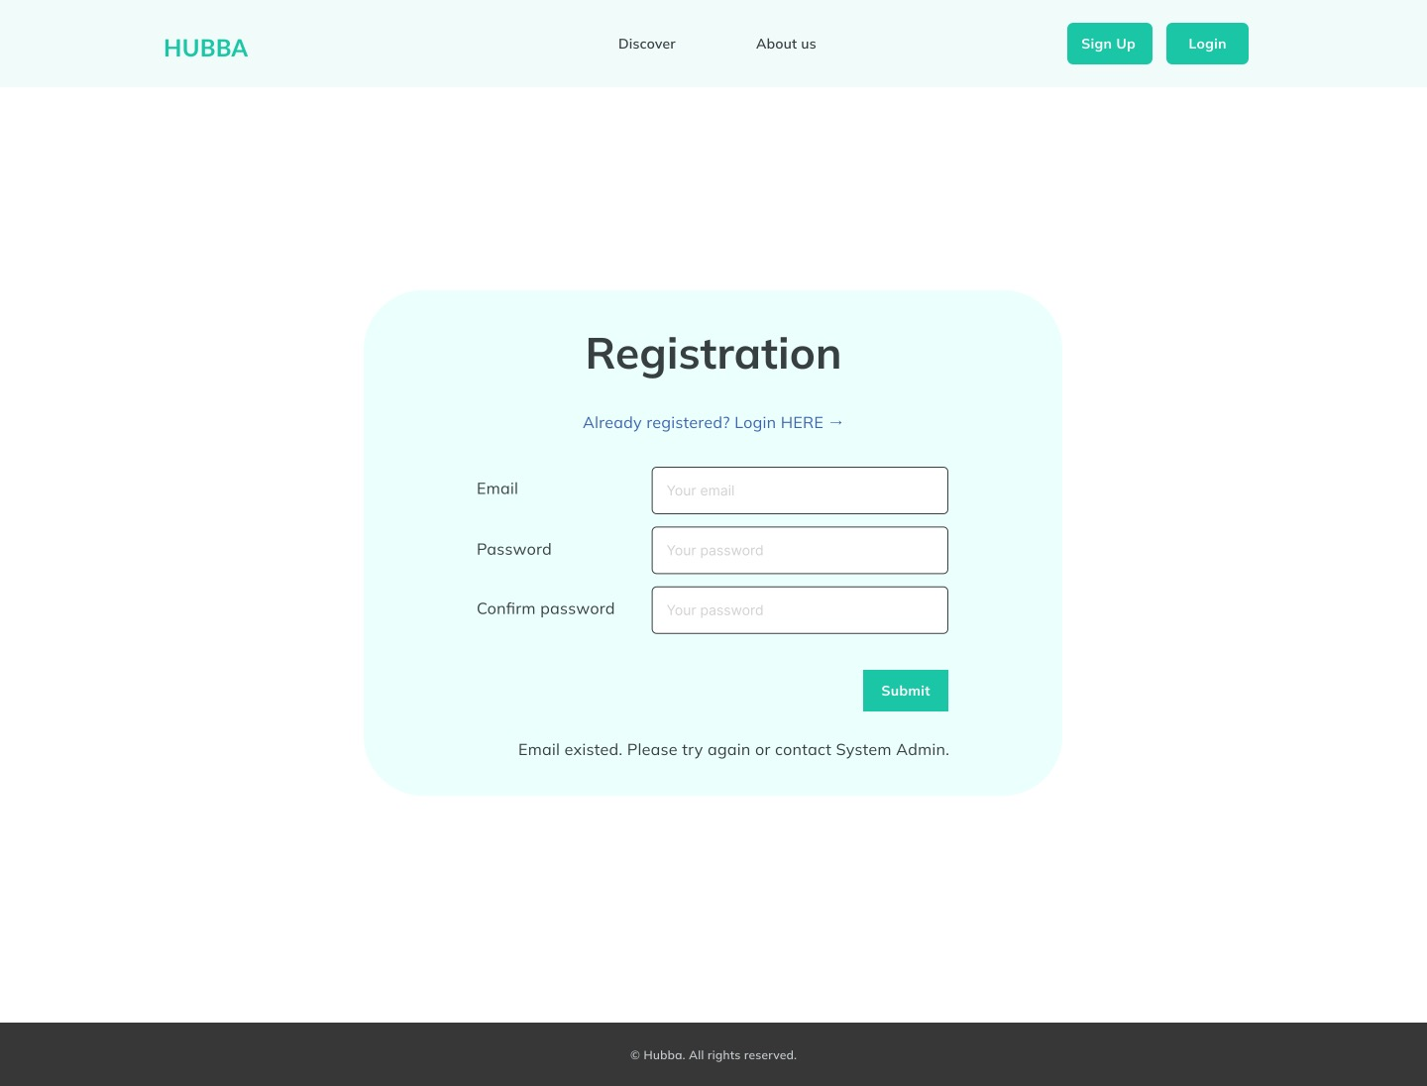

# Registration – Failure Case: Email Existed

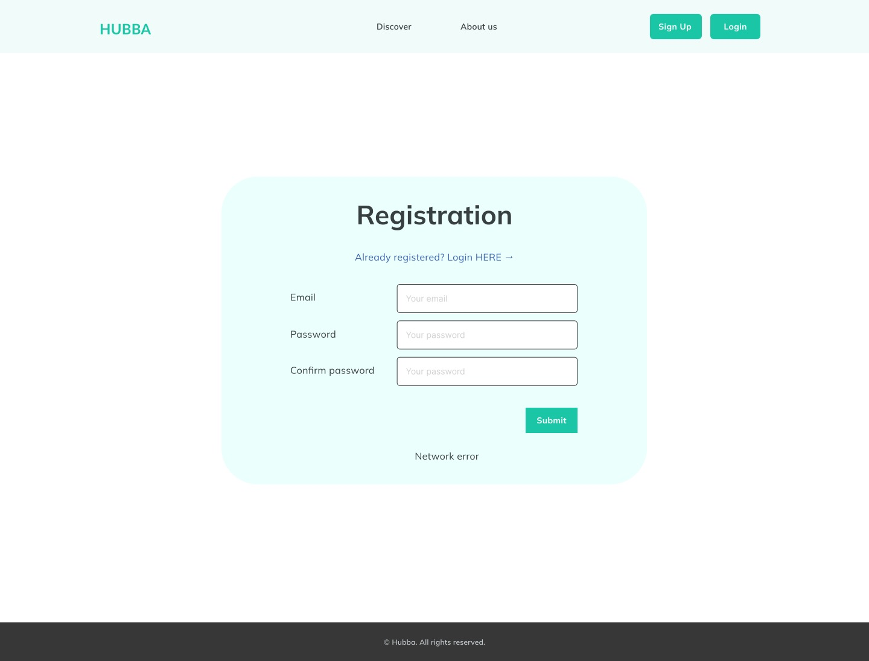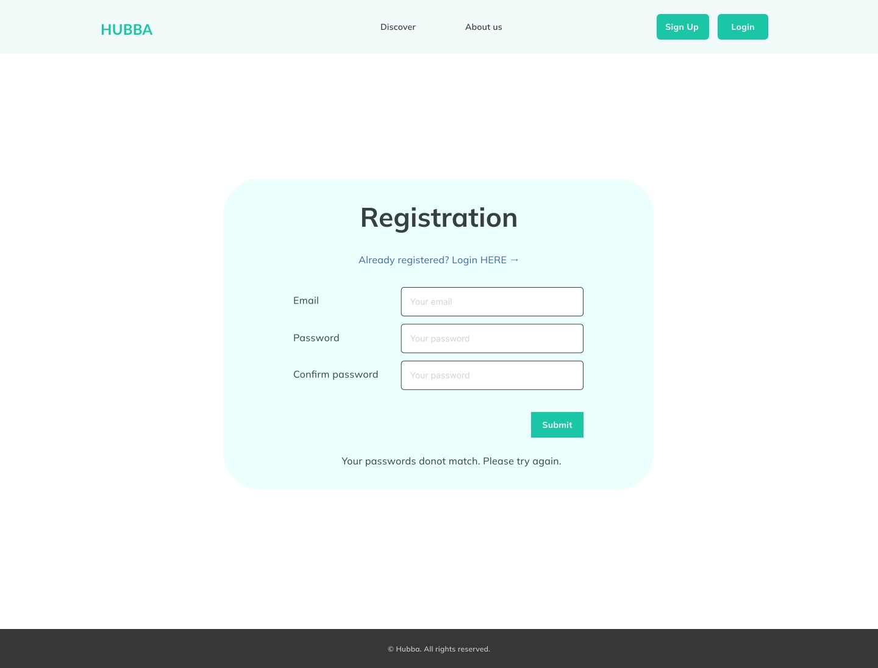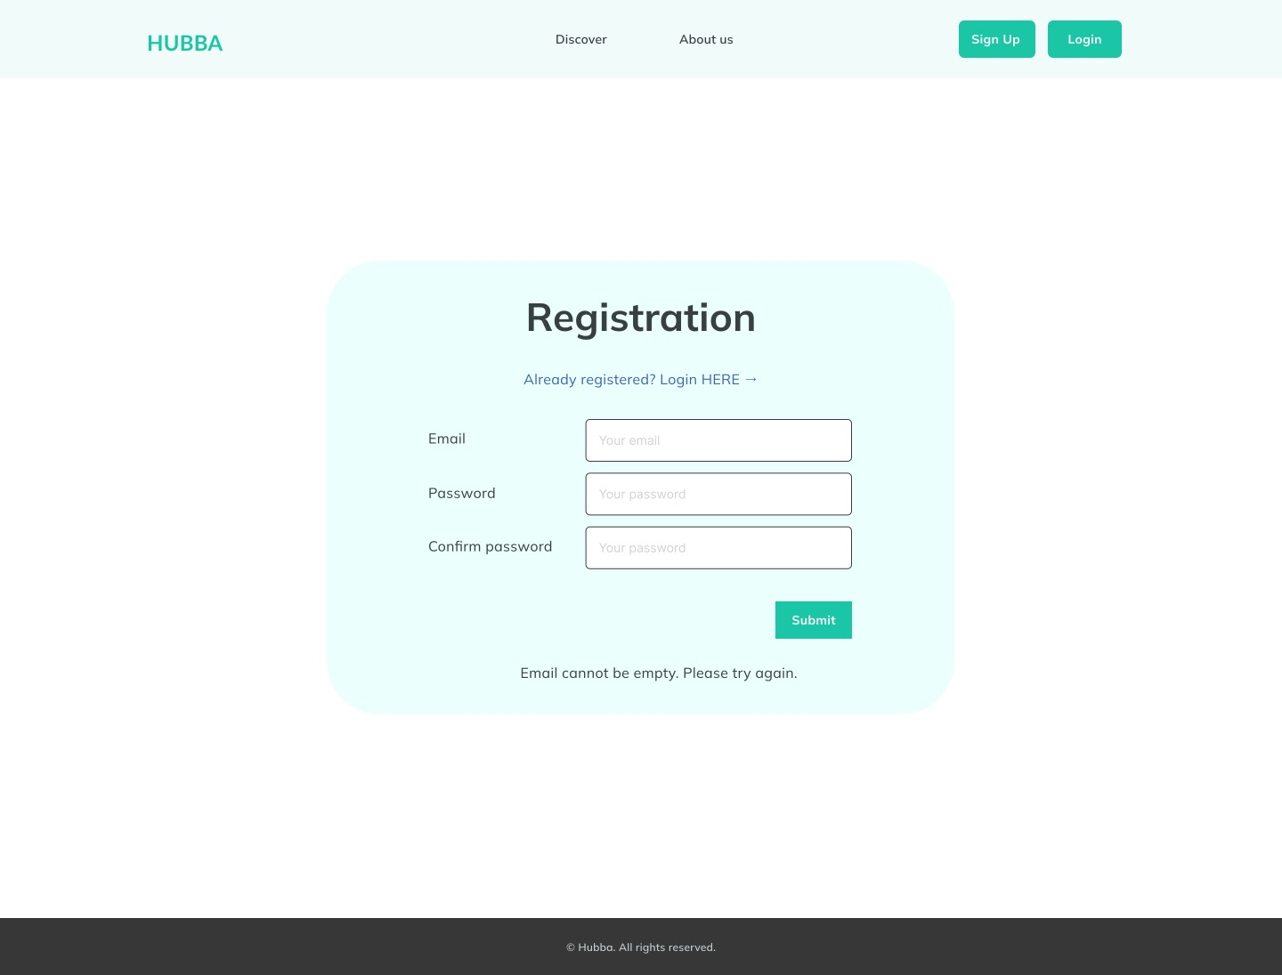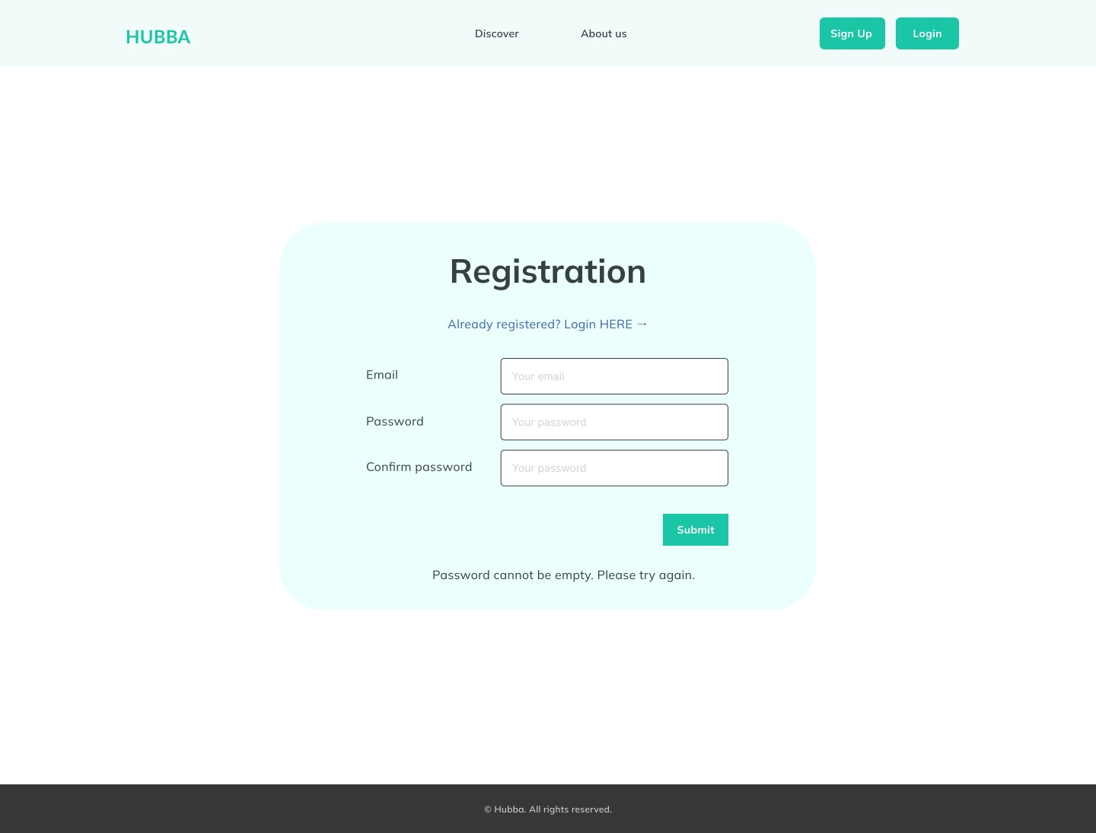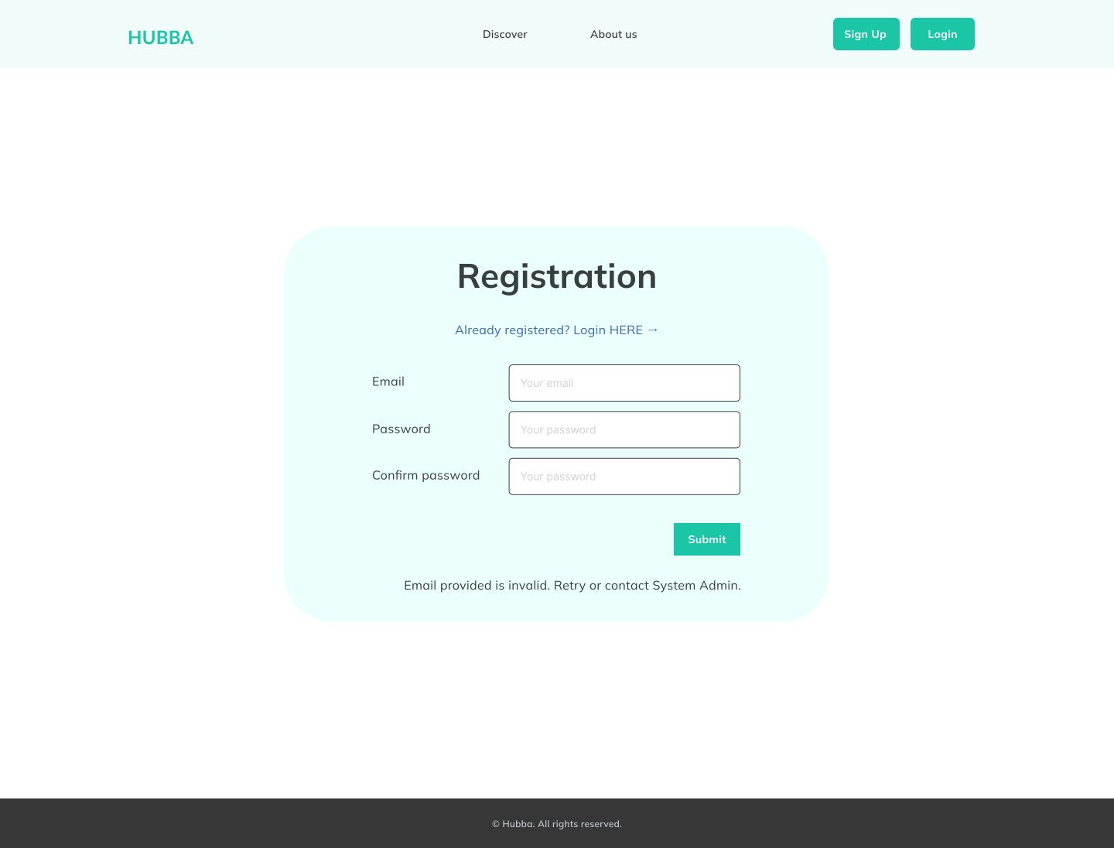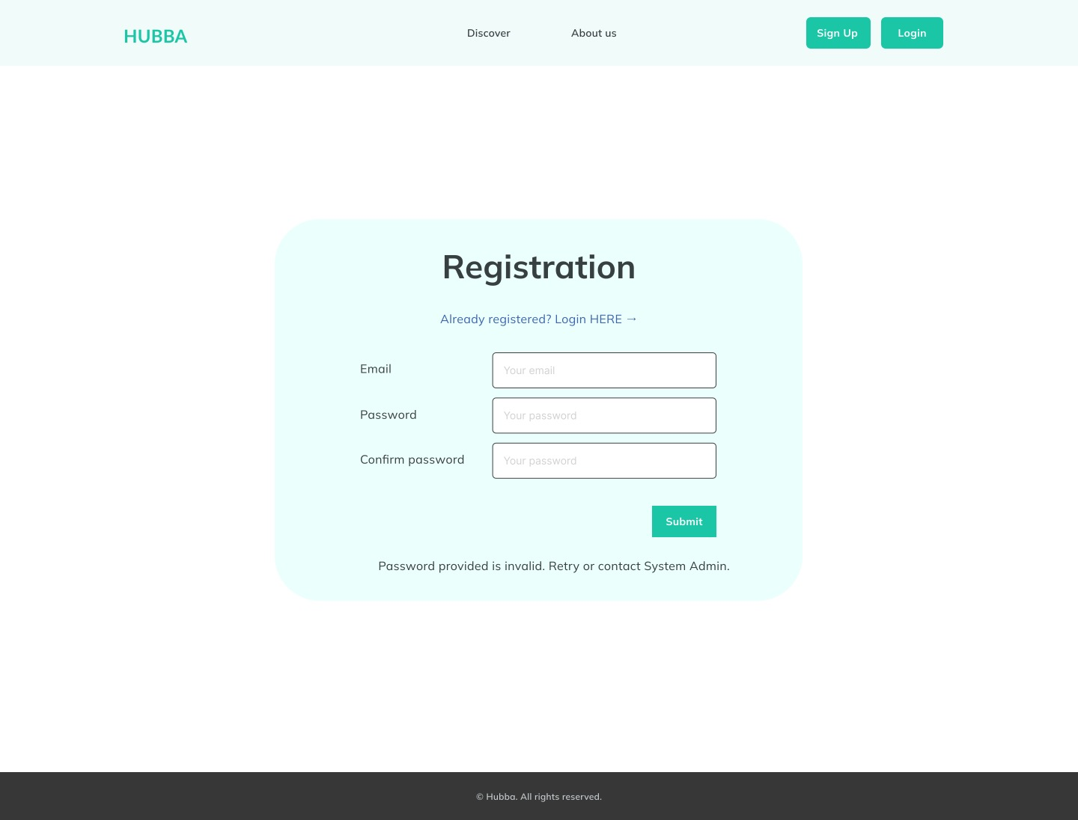

# Registration – Failure Case: Other Error Messages

## Network Error

## Passwords do not match

## Email input field is empty

## Password input field is empty

## Email is invalid

## Password is invalid

# References

The frontend wireframe is designed based on the Registration Low-Level Design Document[1].

The wireframes included in this document utilized Figma[2].

1. Low-Level Design Document, URL: https://github.com/DevelopmentHellaHell/SeniorProject/blob/main/docs/LL%20Design/Common%20Components/Registration/Registration_LLDesign_v.2.0.pdf
2. www.figma.com